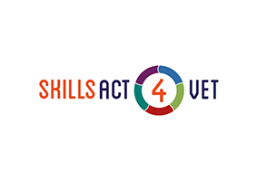
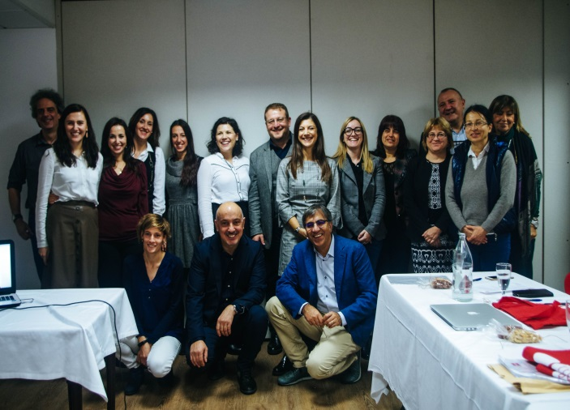

The project meets the strategic aim of enhancing the ability of students to manage their personal growth through a better awareness of themselves and their skills and it aims to provide students with an innovative learning model which supports the development and assessment of transversal skills in a specific learning situation: a short (lasting less than a month) term work-based learning experience abroad.
Our project aims therefore at defining solutions to facilitate the activation of key soft skills during such short-term mobility experiences and therefore promoting a conjunct effort of enterprises, schools and training agencies working together on improving the design and overall implementation of short term VET mobility experiences with the sole objective of improving consistently the impact of such experiences on students and organizations.
Direct target groups are VET students (aged 14-18) experiencing a short term mobility and their teachers preparing and supporting the overall implementation of the related activities. Overall the project aims at reaching directly over 2.000 students and 800 teachers.
Skills Act 4 VET will move towards the following specific objectives:
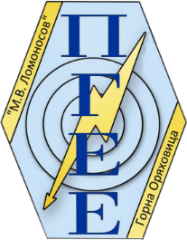
•To design a Transversal Skills Framework with a focus on transversal skills that students can reinforce and
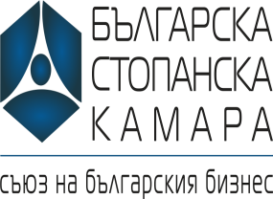
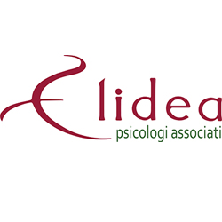

develop during short term work-based learning experiences abroad (Skills Act 4 VET identification tool);
• To develop new and adapt existing tools, methods and resources for an effective preparation and modularised training programme for teachers promoting short term VET mobility projects, able to facilitate students’ awareness raising around their personal growth and skills set;
• To define a methodology and tools (the Work-Based Tasks Map and the Skills Assessment App), that could become a widely used reference at European Level.
The effective implementation of the project activities can only happen within a transnational context, with the active participation of qualified organisations showing an appealing compensating diversity and coming from Spain, Italy, Greece, Bulgaria and Cyprus.

Cyprus
Bulgaria
Italy
Bulgaria
Greece
Spain
Italy

